Hi, Gary

1. Can the function of finding past invoices be added? Sometimes we need to reprint it.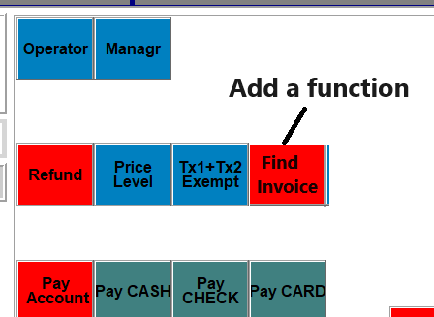
2. Since I changed the client's character set, the Packing Slip is also wrong. The Packing Slip requires 6 changes, please check the below picture. At the bottom of the invoice, you also need to add Page number, Total: number. This way the customer can easily see how many pages there are.

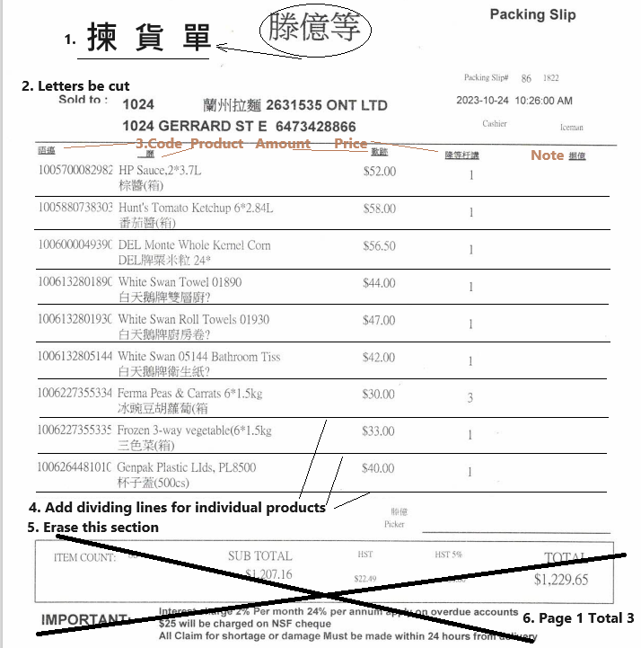

1. I changed the Chinese name of the product in our department (81), and the order was printed normally on the client computer. But for products in other departments, the Chinese names are garbled. I guess because the server was previously set to Simplified Chinese, the character set stored in the database has been changed. I notice that new product names are correct. Can you replace the Chinese names of other departments' products again, but do not change the Chinese names of our department's products?

